Fundraising – Corteo by cirque du soleil
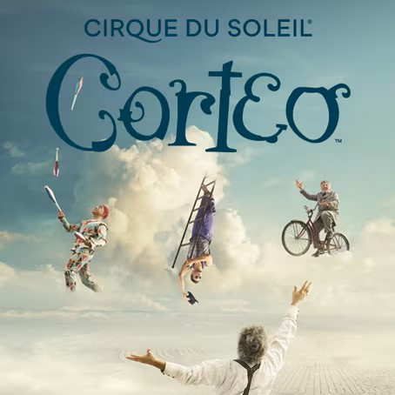  Corteo- cortege in Italian, is a joyous procession, a festive parade imagined by a clown. |  | Purchase tickets to Corteo a family friendly show presented by Cirque Du Soleil  Deadline: Purchase by 3/19/2023 midnight  When: Sundays  4/2 at 5pm  4/9 at 1pm  4/9 at 5pm  4/23 at 1pm  Where: Microsoft Theater DTLA  777 Chick Hearn Ct, Los Angeles, CA 90015  Price: $110, $88, $66  Sign Up Now  Payment: Check or Zelle or Cash  Checks Payable To: CLSSC  (Pleas drop off the check or cash to the front office during school hours)  Zelle: treasurer@westsidechineseschool.org  Tickets will be delivered digitally via AXS app. If you don’t have an account with AXS.com please create one to receive tickets.  Goal: sell 10+ tickets (If goal is not met, event will be cancelled, and refunds will be issued).

Seating Chart

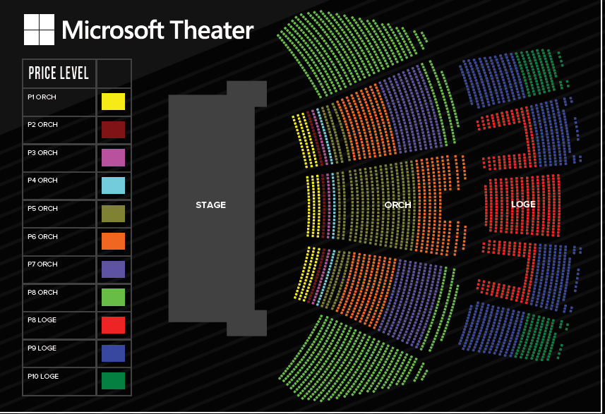

$110: P7 ORCH
$88: P8 LOGE
$66: P9 LOGE

Contact for better seating with higher price
Inquiry: treasurer@westsidechineseschool.org

